# 安裝 mongodb compass

<https://www.mongodb.com/download-center/compass>

左下角 anaconda navigator

# spyder

anaconda prompt

pip install -r <https://linzion.github.io/bot_req/requirements.txt>

[-r recursive]

## requitements.txt

gunicorn

Flask

line-bot-sdk

requests

feedparser

pymongo

pandas

beautifulsoup4

schedule

# 收集外部資料

結果論

通常企業導入訊息蒐集平台累積資料時，距離真正能夠轉換成實際資訊還有很長的距離。可以在蒐集資料的同時，如果有特殊敏感訊息就可以馬上通知。

有實體主管才有感覺....

聊天機器人核心功能就是互動，透過互動方式來服務顧課。希望可以利用互動，更貼近人類溝通

<https://index.12k.co/index/%22Artificial_Intelligence%22,%22Messaging_Apps%22,%22Bots%22,%22Machine_Learning%22>

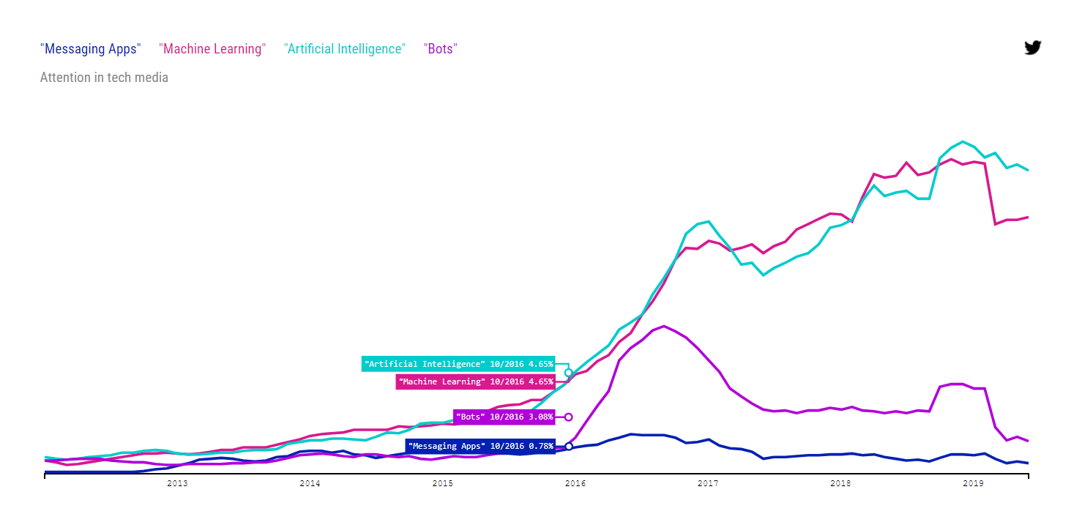

# Chatbot ecosystem (landscape)

<https://www.businessinsider.com/chatbots-explained-why-businesses-should-be-paying-attention-to-the-chatbot-revolution-2016-7>

ecosystem

deployment channels 通訊管道

<https://www.businessinsider.com/chatbots-explained-why-businesses-should-be-paying-attention-to-the-chatbot-revolution-2016-7>

